**Trial and feedback**

14/05/2024

Beginning of project

Start to implement Grid v1.0

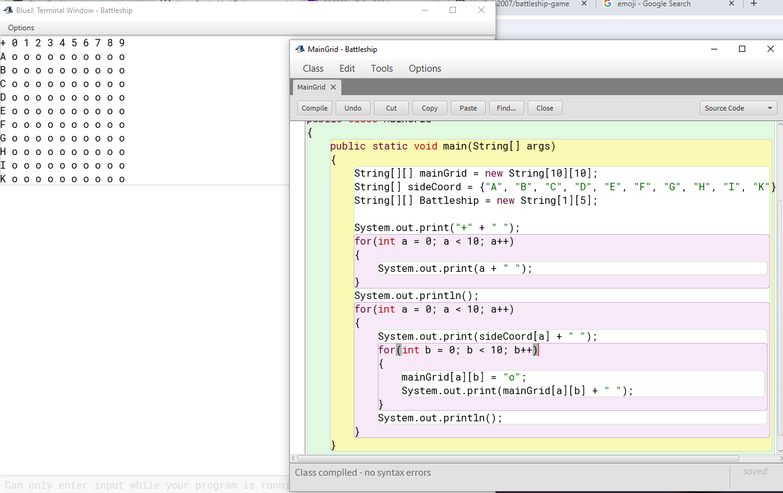

Feedbacks:

“Start the number on top row from one”

“I would remove the + because it looks quite annoying”

*Mr Fairhall*

Grid v1.0.1

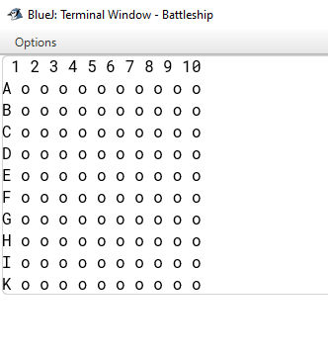

End of day

15/05/2024

Start to implement ships

Idea 1: Take the main grid and input each coordinate there for the ships

Using letter to display the ships

B: Battleship – C: Carrier – C: Cruiser – S: Submarine – D: Destroyer

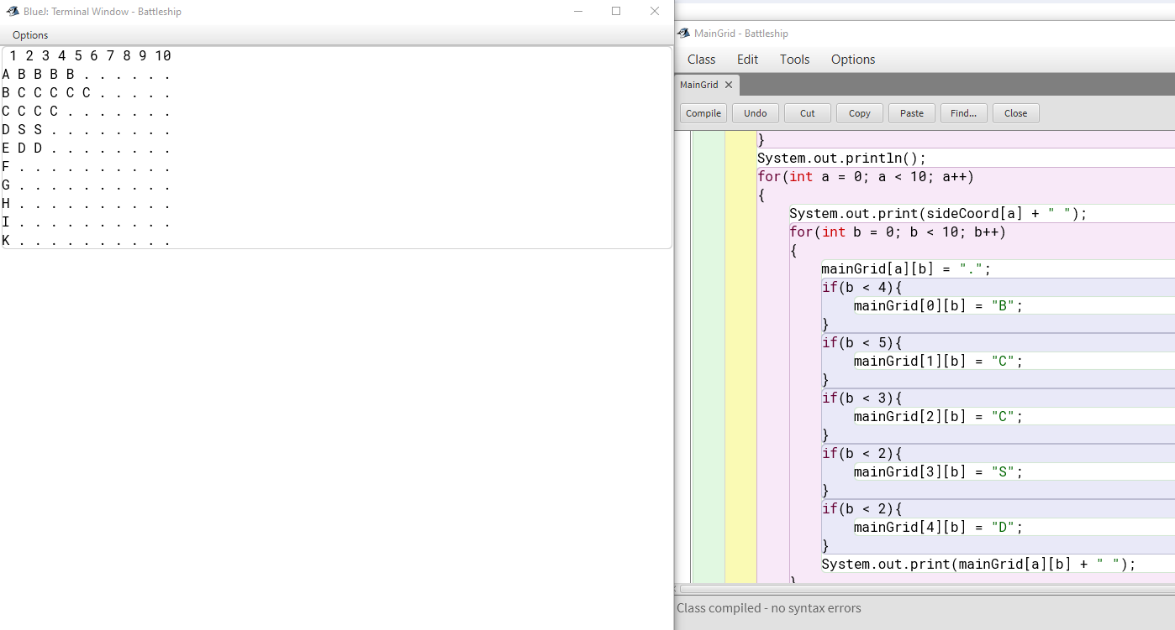

Replace the star ‘square’ into dot ‘square for better viewing of the ships